Name: Farwa Ahmad

Roll number: MCSF19M024

Subject: Mobile Computing Week 1

# Lecture 2 – GitHub.com

* Create Account
* Create Repository
  + Step 1:
  + 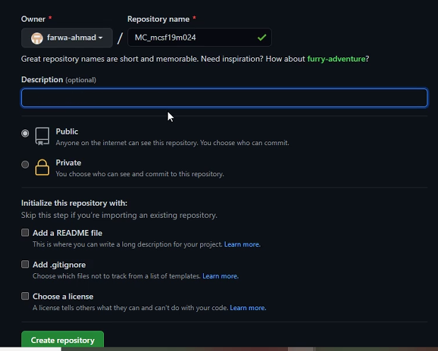Step 2: Name the repository
* Git Clone:
  + 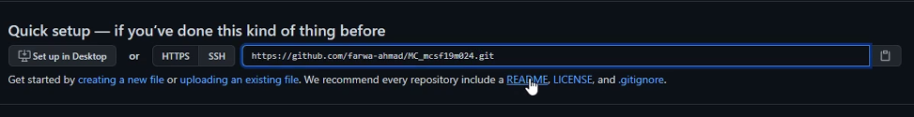Copy link:
  + git clone [URL]



* 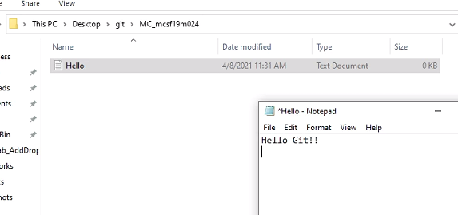How to push code to central repository:
  + 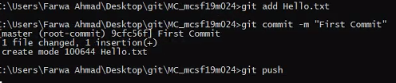Git add, Git Commit – m “Message”, Git Push

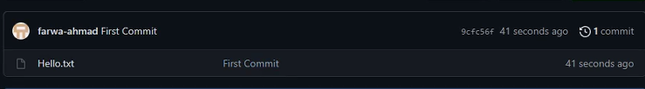

* 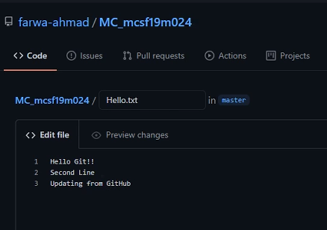Updating from GitHub website and then pulling changes to local repository.

